Automated Detection and Classification of Ki-67 Stained Nuclear Section Using Machine Learning Based on Texture of Nucleus to Measure Proliferation Score for Prognostic Evaluation of Breast Carcinoma

Anil Kumar^{1*}, Manish Prateek¹

Abstract

Background: This study aimed significance of Ki-67 labels and calculated the proliferation score based on the counting of immunopositive and immunonegative nuclear sections with the help of machine learning to predict the intensity of breast carcinoma.

Methods: BreCaHAD (Breast Cancer Histopathological Annotation and Diagnosis) dataset includes various malignant cases of different patients in their routine diagnosis. It contains H&E stained microscopic histopathological images at 40x magnification and stored in .tiff format using RGB band. In this study, the method start with preprocessing that focuses on resizing, smoothing and enhancement. After preprocessing, it is decomposed RGB sample into HSI values. BreCaHAD data set is hematoxylin and eosin (H&E) stained, where brown and blue color level have a major role to differentiate the immunopositive and immunonegative nuclear sections. Blue color in RGB and Hue in HSI are the intrinsic characteristic of H&E Ki-67. The shape parameters are calculated after segmentation preceded by Otsu thresholding and unsupervised machine learning. Morphological operators help to solve the problem of overlapping of nucleus section in sample images so that the counting will be correct and increase the accuracy of automatic segmentation.

Result: With the help of nine morphological features and supported by unsupervised machine learning technique on BreCaHAD dataset, it is predicted the label of breast carcinoma. The performance measures like precision: 95.7%, recall: 93.8%, f-score: 94.74%, accuracy: 0.9088, specificity: 0.6803, BCR: 0.7975 and MCC: 0.5855 are obtained in proposed methodology which is better than existing techniques.

Conclusion: This study developed an efficient automated nuclear section segmentation model implemented on BreCaHAD dataset contains H&E stained microscopic biopsy images. Potentially, this model will assist the pathologist for fast, effective, efficient and accurate computation of Ki-67 proliferation score on breast IHC carcinoma images.

Keywords: Ki-67, immunohistochemistry, breast carcinoma, unsupervised machine learning, tumor grade, prognosis cell proliferation index

Abstract

Background: This study aimed significance of Ki-67 labels and calculated the proliferation score based on the counting of immunopositive and immunonegative nuclear sections with the help of machine learning to predict the intensity of breast carcinoma.

Methods: BreCaHAD (Breast Cancer Histopathological Annotation and Diagnosis) dataset includes various malignant cases of different patients in their routine diagnosis. It contains H&E stained microscopic histopathological images at 40x magnification and stored in .tiff format using RGB band. In this study, the method start with preprocessing that focuses on resizing, smoothing and enhancement. After preprocessing, it is decomposed RGB sample into HSV values. BreCaHAD data set is hematoxylin and eosin (H&E) stained, where brown and blue color level have a major role to differentiate the immunopositive and immunonegative nuclear sections. Blue color in RGB and Hue in HSV are the intrinsic characteristic of H&E Ki-67. The shape parameters are calculated after segmentation preceded by Otsu thresholding and unsupervised machine learning. Morphological operators help to solve the problem of overlapping of nucleus section in sample images so that the counting will be correct and increase the accuracy of automatic segmentation.

Result: With the help of nine morphological features and supported by unsupervised machine learning technique on BreCaHAD dataset, it is predicted the label of breast carcinoma. The performance measures like precision: 95.7%, recall: 93.8%, f-score: 94.74%, accuracy: 0.9088, specificity: 0.6803, BCR: 0.7975 and MCC: 0.5855 are obtained in proposed methodology which is better than existing techniques.

Conclusion: This study developed an efficient automated nuclear section segmentation model implemented on BreCaHAD dataset contains H&E stained microscopic biopsy images. Potentially, this model will assist the pathologist for fast, effective, efficient and accurate computation of Ki-67 proliferation score on breast IHC carcinoma images.

Background

Cancer is a major disease that is affecting human life. Among various diseases, cancer has become one of the enormous threats to human being worldwide. According to the World Cancer Report, up to the year 2020, the instance of fresh cases of cancer patients could be increased to 15 million [6]. The report says that annually 60% of the new cases will occur only from Asia, Africa, South, and Central America. More
than 70% of global death held due to cancer in these

*Correspondence: anil.kumar@ddn.upes.ac.in
¹School of Computer Science, University of Petroleum and Energy Studies, Energy Acre, UPES, Bidholi, via, Prem Nagar, Dehradun, Uttarakhand: 248007, India
regions [5]. In India, around 1 million fresh cases are
diagnosed per year while the proliferation being 2.5 million. Out of the total mortalities of around 700000 per year, cancer causes 6% adult deaths in the country (Ali et al. 2011) [8]. According to Mallath et al. (2014) [7], in India, it is projected the number of deaths per year will increase up to 1.2 million by 2035. Breast cancer is one of the major types of cancer disease, especially in the female. With biological subtypes, breast cancer is identified as a diversified disease. Premature identification of breast carcinoma carries different biomarkers has to identify and is used for monitoring the progression of the disease. It assists the prognosis that authorizes to customize medicine to improve nurse to the patients. Among the different
biomarkers, Ki-67 is accepted as a potential predictive and prognostic biomarker in breast cancer patients. In the early 1980s, a group of German Scientists identified the Ki-67 antigen in Kiel University by use of a mouse mAb averse a nuclear antigen and was discovered in a Hodgkin’s lymphoma cell line [9].
The clinical factors like tumor size, grade, the involvement of lymph node and surgical margins are not enough for making the treatment decisions. Therefore the other factors like estrogen receptor (ER), progesterone receptor (PR) and HER2 have been identified to define the breast cancer subtypes like Luminal A and B, Basal-like and HER2-enriched type [10]. The proliferation index of Ki-67 helps to identify the subtype of breast cancer. Luminal B breast cancer shows higher proliferation index than Luminal A. On the basis of current data observation, the level of Ki-67 above the range 10%-14% mark out a high-risk category in terms of prognosis, and according to Yerushalmi et al. [11]. The expert panel at the St Gallen Consensus in 2009 suggested that the labeling index of Ki-67 is significant for selecting the appendage of radiotherapy and chemotherapy treatment and classified the tumors as low, medium and high proliferated based on the Ki-67 proliferation score of ≤ 15%, 16%-30%, and > 30%, respectively [4]. E. C. Inwald et al. [1] found in their study to assess the standard usage and value of Ki-67 as a prognostic labeling index marker in breast carcinoma to better the clinical therapy and avoid inessential chemotherapy. In early days, the “American Society of Clinical Oncology (ASCO) Tumor Marker Guidelines Committee” did not advise to use of Ki-67 for prognosis with freshly recognized breast carcinoma due to inadequate quality commitment [12]. Recently, the “International Ki-67 in Breast Cancer Working Group” issued their works based on contemporary evidence related to assessment and quantifiable explanation of Ki-67, investigating to make strong bonding between the inter-laboratory affinity and scientific validity of the marker in clinical practice, which is one of the strong biomarker studied and measured by immunohistochemistry (IHC) [1]. Nahed A. Solimen et al. (2016) [3] has also suggested in his original article “Ki-67 as a prognostic marker according to breast cancer molecular subtype”.

The article after working on a total of 107 selected cases of invasive breast carcinoma that proliferation score of Ki-67 may be treated as an effective biomarker and can be used in treatment. The ki-67 abeling index value is a strong biomarker to consider neoadjuvant chemotherapy [13]. Patient with higher cell proliferation score like Ki-67 > 25% may be treated by neoadjuvant chemotherapy. Halla et al. (2018) [2] suggested after studying breast cancer among 92 cases that Ki-67 labeling index expressed by immunohistochemical technique may be observed as a potential biomarker and it can provide prognostic statistics like pathological tumor grading, size and lymph node connection to decide benign or malignant tumor.
After analyzing all the above descriptions and different approaches, it is found that the segmentation is still one of the challenging tasks especially when there are high dimension images in digital pathology. Digital pathology involved the steps in which histology slides are digitized and it produces high-resolution images with the help of high configured whole slide digital scanners. Segmentation helps to find the region of interest and a number of image analysis tasks can be performed like to capture cell nuclear sections, tissue grading (classification) means differentiating cancerous-non cancerous cells, nuclear sections count, feature extraction, etc. Cell nuclear sections detection makes a vital role in the overall segmentation procedure. There are many existing techniques to locate the cell nuclear sections in 2D whole slide microscopic images. Plancoulaine et al. [28] performed Digital Image Analysis (DIA) on whole-slide images (WSI) of 302 surgically removed Ki67 stained breast cancer specimens; the tumor classifier algorithm was used to automatically detect tumor tissue but was not trained to distinguish between invasive and non-invasive carcinoma cells. Cell nuclear sections yield the quantitative information to judge the presence or absence of disease and help to evaluate its impact. To consider this, Liu et al. [14] proposed unsupervised learning for detecting cell nuclear sections and its segmentation using matching-based method and validated on total 25 E&S liver histopathology images and 35 Papanicolaou-Stained thyroid images.

Availability of Data Materials
Aksac et al. (2019) [27] prepared and released the BreCaHAD (Breast Cancer Histopathological Annotation and Diagnosis) dataset contains microscopic histopathological images at 40x magnifier which are stored in uncompressed image format .tiff contains a 3-color band of RGB with 8-bit depth in each band. Breast cell biopsy slides are stained with H&E. It is freely available and accessible on Figshare at https://doi.org/10.6084/m9.figshare.73791 86 [6]. All the necessary ethics approval has been granted by the Health Research Ethics Board of Alberta (HREBA.CC-17-0631). The dataset includes various malignant cases. Dataset of various patients has been collected in this study during their routine diagnosis.
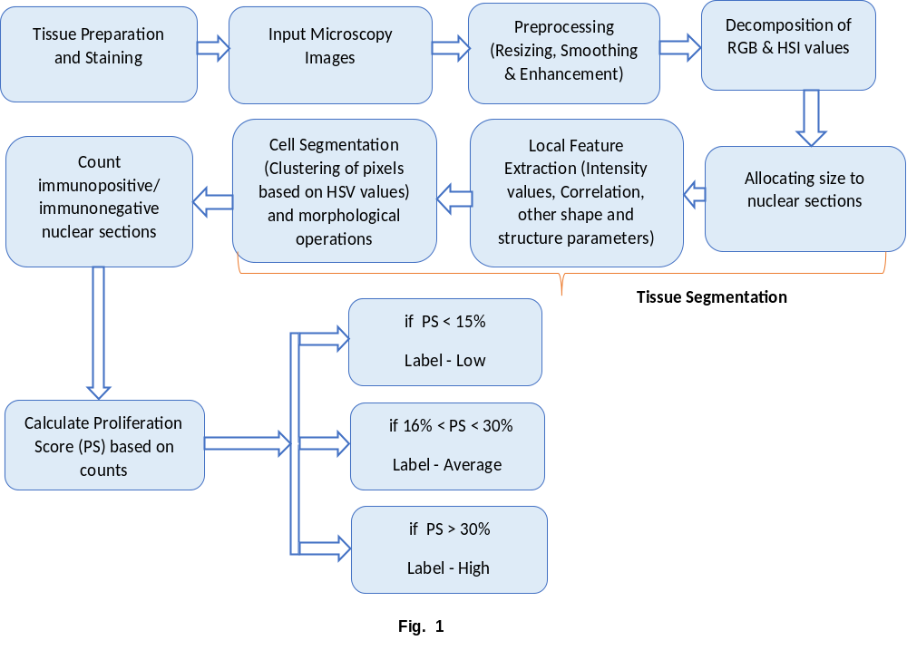

The University of Calgary was responsible for preparedness and digitization of the dataset. No intervention was made with patients for research purposes.

Methods
As all the major steps that efficiently deal with the nuclear section identification and segmentation, pixel clustering based on color intensity as well as shape and structures of nuclear sections is described in Fig. 1. It is confirmed that all the methods were performed in accordance with the relevant guidelines and standard regulations. The decision of benign and malignant cells, as well as prognosis, are dependent on the proliferation score (PS) of the cell. The Ki-67 is the strong biomarker for calculating PS and describing the classification of various cells. This paper proposed an automatic cell nuclear sections detection approach with the help of certain mathematical parameters to enhance the efficiency and reduce the time duration of a pathologist to take an effective decision. The algorithm is coded in python programming language (Python 3.6, 32-bit) that is supported by open source library packages: numpy, sklearn, opencv, imutils, scikit-image, and matplotlib.

Tissue preparation, staining and image acquisition BreCaHAD is a dataset of 162 breast carcinoma biopsy images named as breast cancer histopathology annotation and diagnosis which allow us to assess and improve the performance and effectiveness of our proposed method [15]. With restricted clinical conditions, the pathologist does a biopsy and perform various staining process. In this study, to get the appropriate features of the tissue, the pathologist did hematoxylin and eosin (H&E) staining on histological images that are either annotated as apoptosis, mitosis, tumor nuclear sections, non-tumor nuclear sections, tubule or non-tubule. All the images are saved in uncompressed (.TIFF) format, 3-color band i.e., RGB with 8-bit depth in each band, and resolution of each sample is 1360 x 1024 pixels with a 0.514μm x 0.527μm per pixel at 40x magnification factor. Each slide is manually focused.
Pre-processing of image and decomposition As discussed in Peng Shi et al. 2017 [5], the k-means clustering is a kind of unsupervised learning and it is used to make the clusters of nuclear sections with the same behavior or features. Before using the input images directly for feature extraction, it is always preferred to do pre-processing, as a result, it improves the quality of input images. Usually, H&E stained images have problems like pigment gathering on stained tissues and abnormal distribution of small pigment particles around the tissue. In this paper, it has combined the gaussian filter [15] for smoothing and laplacian filter of size 3x3 for image quality enhancement purpose. It is also used Otsu thresholding technique with different parameters that helped to identify the nuclear sections.
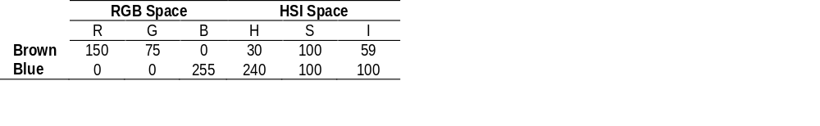
Table 1
Tissue Segmentation. Tissue segmentation comprises three consecutive steps as shown in Fig. 1. The first step is the local feature extraction. Peng Shi et al. (2016) [5] has suggested a few local parameters and it helps to local feature extraction. The first parameter is, B channel (blue color intensity) in RGB and H channel (hue intensity) in HSI color space. Both are intrinsic characteristics of H&E Ki-67. Brown and blue color level have a major role to differentiate the immunopositive and immunonegative nuclear sections. As shown in Table 1, the color intensity of brown is 0 in the blue band and 30 in the hue channels, while the same for blue is much higher 255 and 240 in RGB and HSI color space respectively. The difference between the two bands generates one of the highly relevant features for classification. Because of the characteristics of hematoxylin and eosin both the channels are highly scattered in nuclear sections. To support the above points and decomposition of colors from original images are shown in Fig.2. The second parameter is mean and standard deviation of a single-pixel and its 3 x 3 neighborhood pixels. The third parameter is local texture features that include kurtosis and skewness of a single-pixel and its 3 x 3 neighborhood pixels in blue and hue intensity channel respectively. With the help of chess-board distance measurement and watershed boundaries algorithms, the part of morphological operations, trying to solve the problem of merged and superimposed nuclear sections. For solving such type of problems, it has been suggested a few other mathematical parameters related to formalizing the shape and structure of different nuclear sections, which will improve the automation. Based on the above the information some important shape, structure and morphological features [16] are illustrated in Table 2. At some extent, these parameters will help out to solve the problem related to distorted, merged and superimposed nuclear sections. It is known that the color bands have a vital role to differentiate the nuclear sections and further to segment an image, but it has some limitations. The shape information can be captured through either the contour-based or the region-based approach to extract area irregularity, anticircularity, and contour irregularity of nuclear sections in stained images.

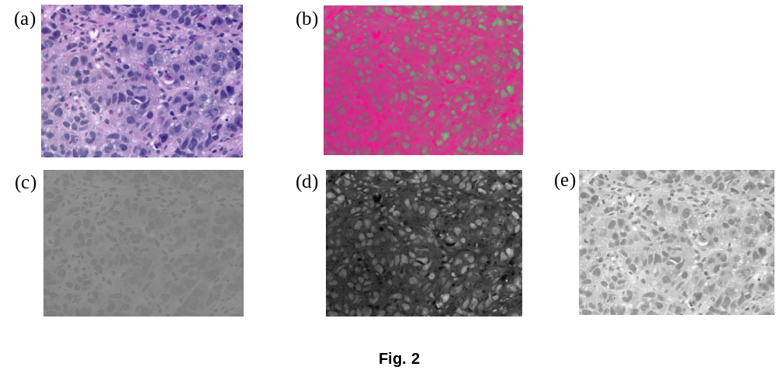
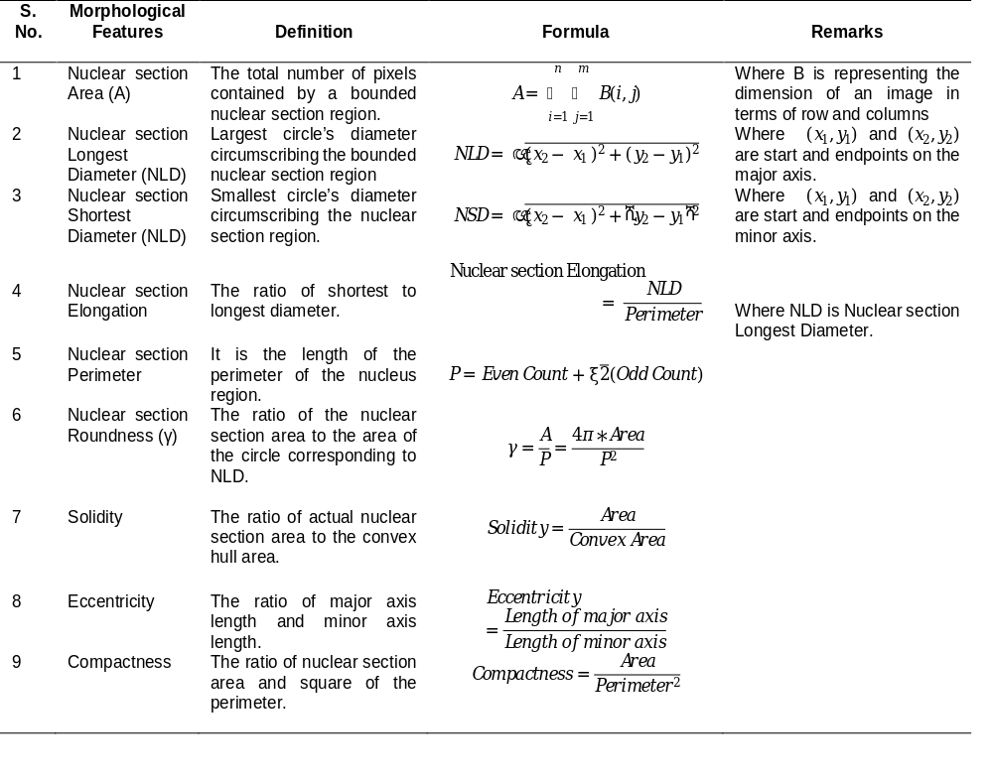
Table 2

On the basis of the shape formula and morphological features from Table 2, it can be extracted the appropriate region of interest that contains the nuclear sections. In Fig 3, it has been illustrated that there are few samples of immunonegative as well as immunopositive nuclear sections. There is a sample of false-positive as well false-negative nuclear section that will help to develop a more effective and optimized algorithm to make a decision. There is a strong correlation between the number of Ki-67 counts and histological cancer grade. For finding the correct counting of immunonegative and immunopositive nuclear sections, the biological and morphological parameter characteristics must be strong. It may be possible that some of the nuclear sections may be wrongly classified that can harm the final proliferation score and the label of cancer. Hence, at some instant, the proposed algorithm is able to improve the result because of the cumulative effect of intensity, shape, and structure parameters on the nuclear section and can reduce the discrepancies.
In Fig.3, it has mentioned a total 21 number of immunopositive nuclear section as part of the sample images have been mathematically and morphologically described in Table 3. It contains the different important parameters that are sufficient to describe the size and structure of any nuclear section like nuclear section radius, area, perimeter, roundness, convexity, solidity, and compactness.
As illustrated in Fig. 4, segmentation is performed using only Otsu’s threshold value on immunopositive nuclear sections and getting corresponding contours mentioned in 4(b) and 4(c). After implementing the formulas of Table 2, it is shown the output in figure 4(d) and found all the immunopositive nuclear sections are circled in yellow boundaries. It shows the effectiveness of the proposed algorithm. Once it is able to count accurately the number of immunopositive and

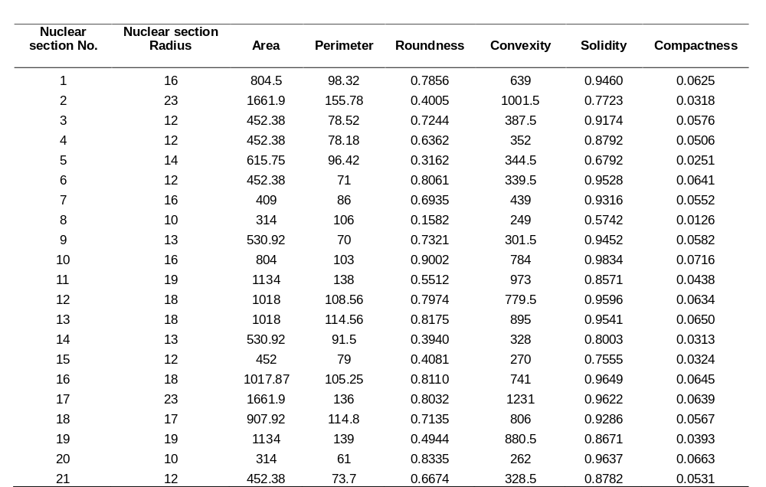
Table 3

Fig. 3(a)
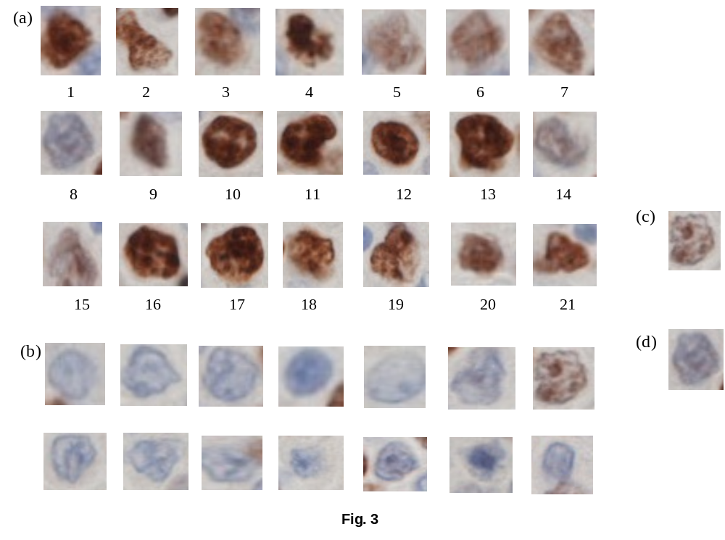

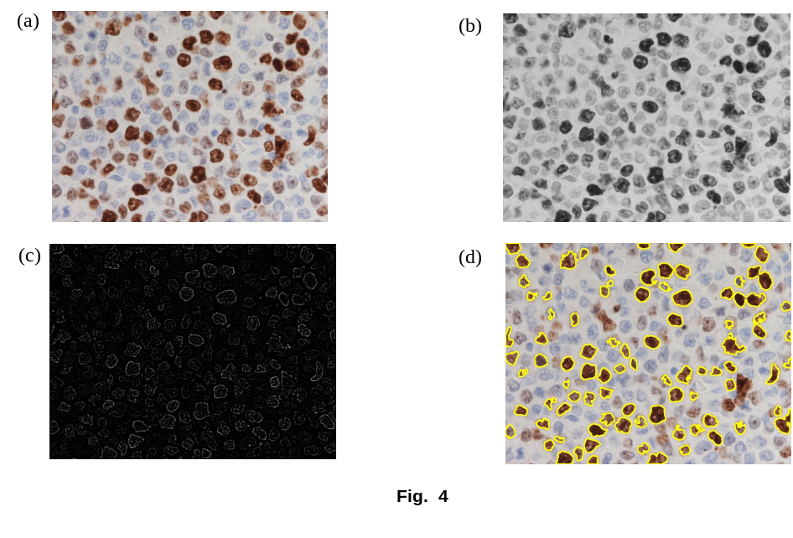

immunonegative nuclear sections, it will be very easy to calculate the proliferation score and to grade the label of cancer. But still, there is a possibility of wrong segmentation due to certain condition and restrictions.

To improve the segmentation process in this paper, it is adopted the k-means clustering algorithm unsupervised learning that will be implemented on HSI images. In Fig. 5, it is presented how the results are changing after converting the same ki-67 stained image into HSI. It is found that, Fig. 5(b) is representing automated segmentation after k-means clustering on sample image 5(a). In this, we can analyze that our algorithm is failed to capture the immunonegative nuclear sections and it is one of the major drawbacks of this approach.

To overcome this fault, this paper has adopted to implement all these algorithms on different HSI channels of the same image. In continuation of this approach, Fig. 5(c) is representing the HSI image and Fig. 5(d) is representing the saturation channel of HSI. Fig. 5(e) is illustrating the output of k-means clustering on the saturation channel. After inverting and applying the automated segmentation we can see and analyze in Fig. 5(g), almost all the immunopositive nuclear sections (brown circles) has been captured and counted by the system that is showing very good accuracy after matching with ground truth.
Till now half part of the calculation has been over. For the next half, to count the immunonegative nuclear sections, that is the major challenging task based on the hue channel of HSI, represented in Fig. 5(h). In Fig. 5(i), it has implemented the k-means clustering algorithm and after inverting it, the output is mentioned in Fig. 5(j). After applying the automated segmentation in Fig. 5(j) we are getting the result as an output in Fig. 5(k), which is inefficient to capture the number of immunonegative nuclear sections. To overcome this limitation, the paper has implemented morphological operators like closing and dilation and the updated result is captured in Fig. 5(l), where most of the immunonegative nuclear sections are yellow circled, which is representing a very good count of immunonegative nuclear sections.
Fig. 5(b), 5(e) and 5(i) are representing the outcomes of unsupervised learning (k-means clustering) algorithm. According to Rajat et al. 2018[17], the k-means clustering method has been implemented on spatial data set, and Ng et al. [29], it is described, a data set {$x^{1}, x^{2},… , x^{m}\}$ and $x^{(i)}∈ R^{n}$.

Algorithm 1 : k-means clustering

- Initialize the cluster centroids $μ_{1}, μ_{2}$,…,$μ_{k }∈ R^{n}$
- Repeat until convergence:

{
For every i, set
$c^{(i) }:=\arg{\min_{j} ||{x^{(i)}}- μ_{j} {||}^{2}}$ (1)
For each j, set
$μ_{j} \text{:=} \frac{\sum_{i=1}^{m}{1 \left\{ c^{\left(i\right)} = j \right\}{ x}^{\left(i\right)} }}{\sum_{i=1}^{m}{1 \{ c^{\left(i\right)} = j \}}}$ (2)
}

Where $μ_{j}$ represents current centroids of clusters in equation (2). ‘||${x^{(i)}}- μ_{j}$||’ is the euclidean distance between$x^{(i)}$ and$μ_{j}$ representing in equation (1).
To converge the k-means algorithm, the distortion function will be
$J\left(c,μ\right)= \sum_{i=1}^{m}{||{x^{(i)}}-μ_{c^{(i)}}{||}^{2}}$ (3)

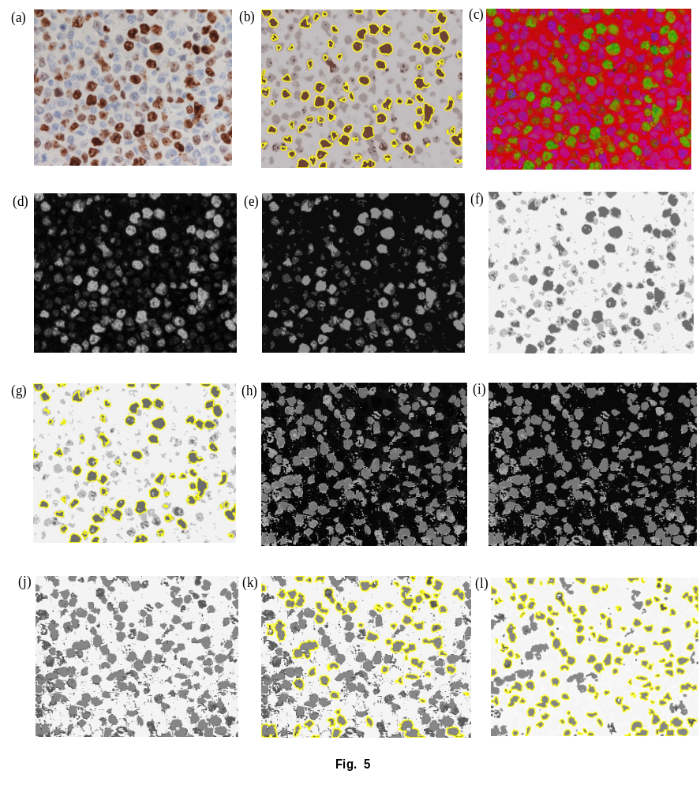

Where J measures the sum of squared distance between $x^{(i)}$ and $μ_{c^{(i)}}$ representing in equation (3). ‘c’ is the number of cluster centers and ‘$c_{i}$’ is the number of data point of $i^{th}$cluster.

Proliferation Score (PS). After all the above calculation and getting the final count of immunopositive and immunonegative nuclear sections, calculate the proliferation score using equation (4) as suggested by Cottenden et al 2018[18],
$Proliferation Score \left(PS\right) OR \left(ki-67 Index\right)=$
$\frac{Number of Immunopositive nuclear sections}{Total number of nuclear sections}$x 100 (4)
Where,
Total number of nuclear sections = Number of Immunopositive nuclear sections + Number of Immunonegative nuclear sections

Under the steps of tissue segmentation, it has to be manually select two points on sample nuclear section either by an experienced pathologist or by consensus of pathologists that will represent the correct diameter of the sample nuclear section. Many times, it may be possible that the user won’t be aware of the magnification of input stained image. In this case, there is a need for manual selection of the correct diameter of the nuclear section to avoid wrong segmentation. After completing, all the above calculation of different parameters and suggested by automatic segmentation of figure 5(g) and 5(l), the counting of immunopositive nuclear sections are 110 and immunonegative nuclear sections are 193. The proliferation score for the known counting after applying equation (4) is calculated by 36.3%. After following the percentage of grading based on proliferation score mentioned in figure 1, it is found that the label of the sample stained image is high.
Another major challenge is the overlapping of the nuclear section that encourages to inaccurately count the number of nuclear sections. It has been observed that due to limitation of acquisition capability, it happens mostly the overlapping of the nuclear section. The problem of overlapping has been mentioned in Peng Shi et al 2017[5] and it has found the solution with the watershed algorithm. It is effectively working but it has also found some limitations. In Fig. 5(l), the paper has implemented morphological operators like closing and dilation. It is helping to split the overlapped nuclear section as well as the unwanted region of interest and increases the counting accuracy. It is discussed more in the result section.
In Fig. 6, it is illustrating the problem of overlapping. Under the steps of tissue segmentation in Fig. 1, it is mentioned to allocating size to nuclear section. It is not possible that the size of nuclear sections will be fixed for all samples as well each level of magnification. As this method is assisting to the pathologist for prediction purpose, so with the consent of user (pathologist), it will be selected two points on sample image that will be strongly directed for the diameter of the nuclear section. This part of consent is not required for this study. It is known that the counting is a major issue for grading cancer and overlapping of the nuclear section can affect the results. To minimize this, calculate the area of the ideal nuclear section as already mentioned by the user (pathologist). The shape and morphological structure parameters mentioned in Table 2, will help to calculate the area and other parameters. There will be threshold band for the area of the region and other parameters like roundness, solidity, compactness, etc. of the nuclear section. If the area will be less than the lower threshold band, it will be considered as no nuclear section and it will not be counted. If the measured parameters are in between lower and upper band it will be counted as one. Otherwise, if the area is above the upper band of the threshold value, generally it will be the case of overlapping and algorithm will increase the number of counts accordingly.
.The effectiveness and performance of the above classifier are judged over confusion matrix, for which it is calculated the value of True Positive(TP), True Negative(TN), False Positive(FP) and False Negative(FN). The definition and formula are illustrated below:
Accuracy. Accuracy of any classification method defined as the counting of correctly classified samples i.e., TP and TN and is shown as [20]:
$Accuracy= \frac{TP+TN}{N}*100$ (5)
Where, $N=TP+TN+FP+FN$
Sensitivity. The sensitivity is defined as the ratio of positive samples which are rightly classified [21] and is calculated as:
$Sensitivity= \frac{TP}{FN+TP}$ (6)
Where the value of sensitivity ranges from 1 and 0, respectively mean best and worst classification.
Specificity. The specificity is defined as the ratio of negative samples which are rightly classified [22]. It is shown as:
$Specificity= \frac{TN}{FP+TN}$ (7)
The value of specificity ranges from 1 and 0, respectively mean best and worst classification.
F-Measure. It is defined as the harmonic mean of recall and precision. It is shown as:
$Precision= \frac{TP}{FP+TP}$
$Recall= \frac{TP}{FN+TP}$
F$-Measure= 2* \frac{Precision* Recall}{Recall+Precision}$ (8)
The value of F-measure ranges from 1 and 0 means best and worst classification respectively.
Balanced Classification Rate (BCR). It is defined as the geometric mean of sensitivity and specificity is

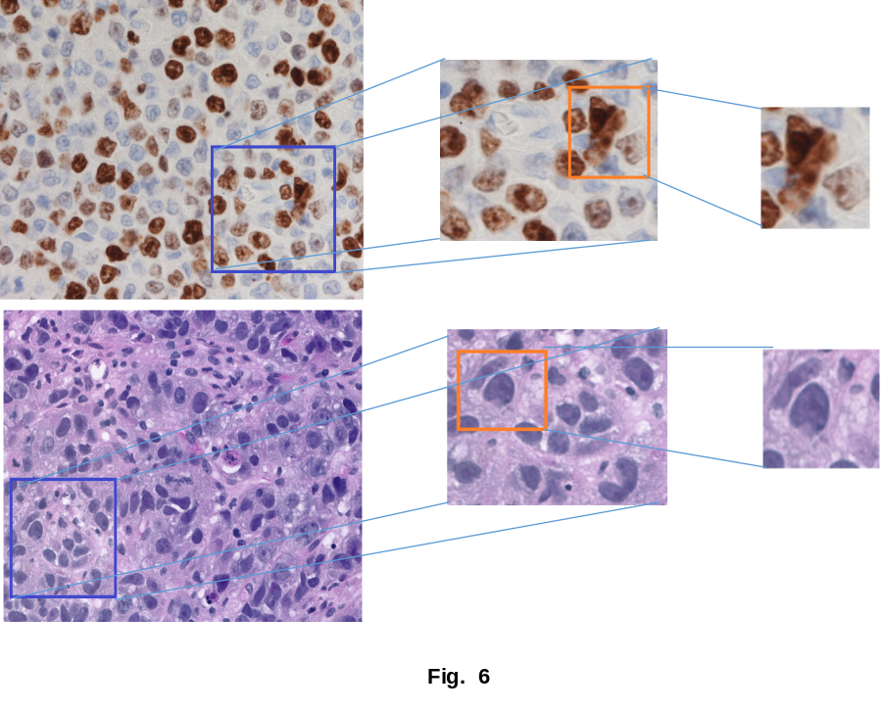

recognized as balanced classification rate [23, 24]. It is shown as:
$BCR= \sqrt{Sensitivity*Specificity}$ (9)
Mathew’s Correlation Coefficient MCC). It is a measure of the eminence of binary classifications [23]. It is defined as:
$MCC=\frac{TN*TP-FN*FP}{\sqrt{(\left(FN+TP\right)\left(FP+TP\right)\left(FN+TN\right)\left(FP+TN\right))}}$(10)
The measure of MCC ranges from -1 to +1, where -1, +1 and 0, are worst, best and at random predictions respectively.
Ethics and consent statements. Breast Cancer Histopathological Annotation and Diagnosis (BreCaHAD) dataset is freely available and accessible on Figshare at https://doi.org/10.6084/m9.figshare.73791 86. All the necessary ethics approval has been granted by the Health Research Ethics Board of Alberta (HREBA.CC-17-0631) [27].

Results
For the validation of our proposed method, it is using the total 21 H&E stained BreCaHAD dataset mentioned in Aksac et al. [27], which allows the researcher to optimize, evaluate and usefulness of the proposed algorithm. The images have the dimension of 1360 x 1024 with 40x magnifier in uncompressed (.TIFF) image format. The method is written in python programming language and deployed on PC with a configuration of 2GHz CPU and 4 GB RAM. It took 7.4 seconds on an average to execute the single sample. If the configuration of the system will be improved, it will reduce the execution time and will adequate to meet the clinical real-time requirements. It is compared and confirmed the automated nuclear section segmentation against the manual nuclear section segmentation, and also evaluated the consistency after counting of nuclear sections for proposed algorithm in Table 4.

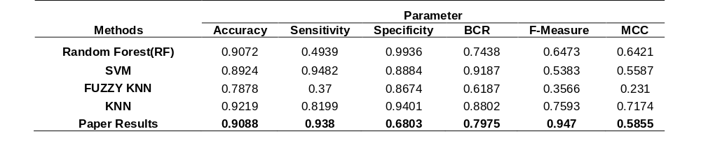
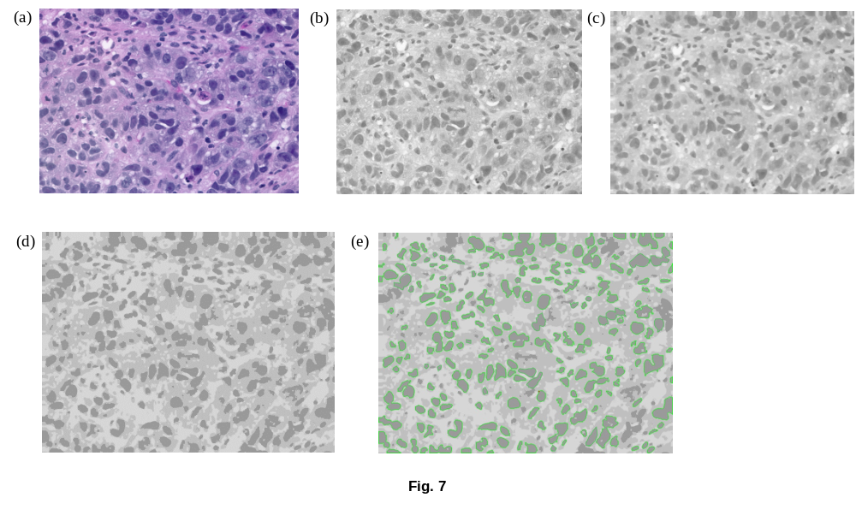
Table 4

In Table 4, it is representing the performance comparison of the proposed model with other existing algorithms. It is observed that after applying this algorithm on 21 BreCaHAD datasets [27], the value of F-score is recommendable, accuracy is approximate 0.9088, and sensitivity is 0.938 which also better than others, BCR is 0.7975 which is also better than Random Forest and Fuzzy KNN. In the same way, Table 5 representing the performance comparison between different algorithms and the proposed algorithm. It is found that the proposed algorithm has achieved the best precision is about 95.7%, recall is 93.8% and F-score is 94.75%, overall it is better than all the other algorithms. In Fig. 7, it is observed that to solve the problem of overlapping of nuclear sections, it has been imposed conditions on structural parameters of nuclear sections like area, roundness, solidity, convexity, and compactness. To solve the above problems, it is applied to morphological operators closing and dilation to make more accurate segmentation of nuclear sections. As a result, most of the output is matching with ground truth counting.
Fig. 7(c) is representing the results of dilation preceded by closing with identity kernel of size 2x2 matrix on input image 7(b). It is found that after dilation based on equation (11) is expanding the boundary structure of element ‘A’ with support of kernel ‘B’ as described by Gonzalez et al. (2002) [26]
$A⊕B=\{z|\left\langle \hat{B}\right.$〉_{z} ⋂ A≠𝜙} (11)

Closing is used for the purpose of smoothing the contours, fuses narrow breaks and eliminates small holes. Equation (12) is describing the closing operator

$A ⦁ B=\left(A⊕B\right)⊖B (12)$

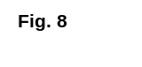

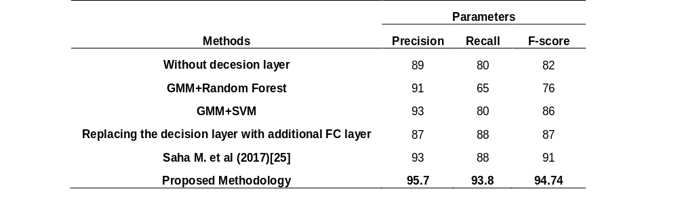
Table 5

Equation (11) and (12) are impacting the accuracy of the final output. The sample image has a variation in terms of noise and it is also possible the overlapping of the nuclear sections. In the presence of all these challenges, it is very difficult to achieve accurate segmentation. To make comfortable segmentation of nuclear sections it is better to focus on the problem and issues that are affecting the final result and accordingly adopt the steps. In short, sometimes, it is also a kind of hit and trial methodology. All the comparison with graphical representation of segmentation algorithm with different performance parameters are shown in Fig. 8.

Discussion
In this manuscript, we developed an efficient automated nuclear section segmentation model that effectively working on BreCaHAD dataset [27] contains H&E stained microscopic biopsy images. The final grading of the sample image is done on the basis of the proliferation score that depends on the counting of Ki-67 antigen. The proposed algorithm is very suitable to count it with any IHC biopsy image included immunopositive nuclear sections will be manifested as brown and immunonegative nuclear sections will be an as blue color. Suggested model can work efficiently on any magnification of sample image because the size of the diameter of the sample nuclear section is always defined by the experienced pathologist or the group of pathologists. After defining the diameter of the nuclear section, the model will automatically compare the seed hotspot to another hotspot and capture almost all hotspots supported by different parameters mentioned in Table 3. The different mode of results either in quantitative or in qualitative ways showed that our model performs better when it is measured by a recall, precision, and F-score i.e., 93.8%, 95.7%, and 94.74% respectively, in comparison with other effective approaches listed in Table 4. Potentially, this model will be highly supportive to the pathologists for fast, effective, efficient and accurate computation of Ki-67 proliferation score on breast IHC carcinoma images. As the number of the sample increases, it will improve the accuracy and other dimensions of the model.

Conclusion
In this study we evaluated and compared the performance of proposed methodology in the task of effective segmentation of nuclear sections in BreCaHAD image dataset. The counting of different types of nuclear sections are followed by segmentation technique. The correct counting of immunopositive and immunonegative nuclear sections are used to calculate the proliferation score that helps to predict the label of carcinoma in BreCaHAD images.

A quantitative analysis showed that it can assist the pathologist to take the decision regarding the grading of breast cancer based on Ki-67 antigen bio and prognostic marker. However, the number of samples can increase the effectiveness of the methodology and will help to get better results. As future work, the proposed algorithm can be applied to WSI (Whole Slide Images) and other frequent types of annotated sample image.

Declarations

Abbreviations
BreCaHAD: Breast Cancer Histopathological Annotation and Diagnosis; H&E: Hematoxylin and Eosin; HSI/HSV: Hue, Saturation and Intensity/Value; IHC: Immunohistochemistry; ASCO: American Society of Clinical Oncology; DIA: Digital Image Analysis; PS: Proliferation Score; TIFF: Tagged Image File Format; RGB: Red Green Blue; ER: Estrogen Receptor; PR: Progesterone Receptor; HER2: Human Epidermal growth factor Receptor 2; NLD: Nuclear section Longest Diameter; NSD: Nuclear section Shortest Diameter; BCR: Balanced Classification Rate; MCC: Mathew’s Correlation Coefficient; CPU: Central Processing Unit; RAM: Random Access Memory; SVM: Support Vector Machine; KNN: k – Nearest Neighbor; GMM: Gaussian Mixture Model; FN: False Negatives; FP: False Positives; GB: Giga Bytes; TN: True Negatives; TP: True Positives; WSI: Whole Slide Image; FC: Fully Connected; HREBA: Health Research Ethics Board of Alberta

Ethics approval and consent to participate
Alper Aksac, University of Calgary, Canada is copyright holder of BreCaHAD dataset, has granted the permission letter. Based on that prepared the manuscript.

Consent for publication
Not applicable.

Availability of data and material
The BreCaHAD data that support this study will be provided upon request to the authors, only for academic research purposes and with the commitment to cite this work.

Competing interests
The authors declare that they have no competing interests.

Funding
Not Applicable.

Authors’ contributions
Conception and design of the work: AK. Data collection: AK. Drafting the article: AK. Final approval of the article: MP. All authors have read and approved the manuscript.

Acknowledgements
Alper Aksac, copyright holder of BreCaHAD datset has granted the permission letter.

Author details
¹School of Computer Science, University of Petroleum and Energy Studies, Energy Acre, UPES, Bidholi, via, Prem Nagar, Dehradun, Uttarakhand: 248007, India.

References
- E. C. Inwald, M. Klinkhammer-Schalke, F. Hofsta¨dter, F. Zeman, M. Koller, M. Gerstenhauer, O. Ortmann. Ki-67 is a prognostic parameter in breast cancer patients: results of a large population-based cohort of a cancer registry, Breast Cancer Res Treat (2013) 139:539–552, DOI 10.1007/s10549-013-2560-8
- Halla Mohamed Ragab, Nervana Samy, Mie Afify, Nabila Abd El Maksoud, HebatAllah Mohamed Shaaban. Assessment of Ki-67 as a potential biomarker in patients with breast cancer. Journal of Genetic Engineering and Biotechnology (2018)
- Nahed A. Soliman1, Shaimaa M. Yussif2. Ki-67 as a prognostic marker according to breast cancer molecular subtype. Cancer Biol Med 2016. doi: 10.20892/j.issn.2095-3941.2016.0066
- W. Jonat & N. Arnold. Is the Ki-67 labelling index ready for clinical use? Annals of Oncology 22: 500–502, 2011, doi:10.1093/annonc/mdq732
- Peng Shi, Jing Zhong, Jinsheng Hong, Rongfang Huang, Kaijun Wang & Yunbin Chen, ”Automated Ki-67 Quantification of Immunohistochemical Staining Image of Human Nasopharyngeal Carcinoma Xenografts”, (2017). Scientific Reports | 6:32127 | DOI: 10.1038/srep32127
- Frederique Penault-Llorca and Nina radosevic-Robin. Assessment in breast cancer: an update. Pathology (February 2017) 49(2), pp. 166–171
- Mallath MK, Taylor DG, Badwe RA, Rath GK, Shanta V, Pramesh CS, Digumarti R, Sebastian P, Borthakur BB, Kalwar A, Kapoor S, Kumar S, Gill JL, Kuriakose MA, Malhotra H, Sharma SC, Shukla S, Viswanath L, Chacko RT, Pautu JL, Reddy KS, Sharma KS, Purushotham AD, Sullivan R, “The growing burden of cancer in India: epidemiology and social context”, Lancet Oncol. 2014 May;15(6):e205-12. doi: 10.1016/S1470-2045(14)70115-9. Epub 2014 Apr 11.
- Imran Ali, Waseem A. Wani, and Kishwar Saleem, “Cancer Scenario in India with Future Perspectives”, (Research Article) Cancer Therapy Vol 8, 56-70, 2011.
- Gerdes J, Schwab U, Lemke H, Stein H. Production of a mouse monoclonal antibody reactive with a human nuclear antigen associated with cell proliferation. Int J Cancer 1983; 31: 13–20
- Perou CM, Sørlie T, Eisen MB, van de Rijn M, Jeffrey SS, Rees CA, et al. Molecular portraits of human breast tumors. Nature. 2000; 406: 747–52.
- Yerushalmi R, Woods R, Ravdin PM et al. Ki67 in breast cancer: prognostic and predictive potential. Lancet Oncol 2010; 11: 174–183.
- Harris L, Fritsche H, Mennel R, Norton L, Ravdin P, Taube S, Somerfield MR, Hayes DF, Bast RC Jr (2007) American Society of Clinical Oncology 2007 update of recommendations for the use of tumor markers in breast cancer. J Clin Oncol 25(33): 5287–5312
- Nishimura R, Osako T, Okumura Y et al. Clinical significance of Ki-67 in neoadjuvant chemotherapy for primary breast cancer as a predictor for chemosensitivity and for prognosis. Breast Cancer 2010; 17(4): 269–275.
- Liu C, Shang F, Ozolek JA, Rohde GK. Detecting and segmenting cell nuclear sections in two-dimensional microscopy images. J Pathol Inform 2016;7:42.
- Van Vliet, L. J., Young, L. T. & Verbeek, P. W. Recursive gaussian derivative filters., 1998. proc. of Fourteenth International Conference on Pattern Recognition, Brisbane, Qld. 1, 509–514 (1998).
- Rajesh Kumar, Rajeev Srivastava, and Subodh Srivastava, ”Detection and Classification of Cancer from Microscopic Biopsy Images Using Clinically Significant and Biologically Interpretable Features”, Journal of Medical Engineering Volume 2015 (2015), Article ID 457906, 14 pages
- Bhowmick, R. S., Kumar, A., Singh, G. D., and Kumar, S.: MODEL FOR LAND COVER ESTIMATION USING UNSUPERVISED MACHINE LEARNING ON GOOGLE MAPS COLOR IMAGES, Int. Arch. Photogramm. Remote Sens. Spatial Inf. Sci., XLII-5, 147-154, 2018
- Jennielee Cottenden, MD; Emily R. Filter, MD, FRCPC; Jon Cottreau, MD; David Moore, MMedSc; Martin Bullock, MD, FRCPC; Weei-Yuarn Huang, PhD, MD, FRCPC; Thomas Arnason, MD, FRCPC, “Validation of a Cytotechnologist Manual Counting Service for the Ki67 Index in Neuroendocrine Tumors of the Pancreas and Gastrointestinal Tract”, Arch Pathol Lab Med—Vol 142, March 2018
- Cite for Figure: Ki-67 stained image: https://www.memorangapp.com/flashcards/60092/1.01+-+Cell+Cycle+Control/
- T. Ojala, M. Pietik¨ainen, and T. M¨aenp¨a¨a, “Multiresolution gray-scale and rotation invariant texture classification with local binary patterns,” IEEE Transactions on Pattern Analysis and Machine Intelligence, vol. 24, no. 7, pp. 971–987, 2002
- L. Wei, Y. Yang, and R. M. Nishikawa, “Microcalcification classification assisted by content-based image retrieval for breast cancer diagnosis,” Pattern Recognition, vol. 42, no. 6, pp. 1126–1132, 2009.
- G. Lalli, D. Kalamani, and N. Manikandaprabu, “A perspective pattern recognition using retinal nerve fibers with hybrid feature set,” Life Science Journal, vol. 10, no. 2, pp. 2725–2730, 2013.
- Y. Yang, L.Wei, and R. M. Nishikawa, “Microcalcification classification assisted by content-based image retrieval for breast cancer diagnosis,” in Proceedings of the 14th IEEE International Conference on Image Processing (ICIP ’07), vol. 5, pp. 1–4, September 2007.
- L. Hadjiiski, P. Filev, H.-P. Chan et al., “Computerized detection and classification of malignant and benign microcalcifications on full field digital mammograms,” in Digital Mammography: 9th International Workshop, IWDM 2008 Tucson, AZ, USA, July 20–23, 2008 Proceedings, E. A. Krupinski, Ed., vol. 5116 of Lecture Notes in Computer Science, pp. 336–342, Springer, Berlin, Germany, 2008.
- Monjoy Saha, Chandan Chakraborty, Indu Arun, Rosina Ahmed, and Sanjoy Chatterjee, ”An Advanced Deep Learning Approach for Ki-67 Stained Hotspot Detection and Proliferation Rate Scoring for Prognostic Evaluation of Breast Cancer,” Scientific Reports 7, Article number: 3213 (2017)
- Rafael C. Gonzalez, Richard E. Woods, Digital Image Processing, Second Edition, Prentice-Hall, Upper saddle River, New Jersey 07458, 2002
- Aksac A, Demetrick DJ, Özyer T, Alhajj R. BreCaHAD: A Dataset for Breast Cancer Histopathological Annotation and Diagnosis. Figshare. 2018. https://doi.org/10.6084/m9.figsh are.73791 86.
- Plancoulaine B., Laurinaviciene A., Herlin P., Besusparis J., Meskauskas R. ,Baltrusaityte I., Iqbal Y, Laurinavicius A., “A methodology for comprehensive breast cancer Ki67 labeling index with intra-tumor heterogeneity appraisal based on hexagonal tiling of digital image analysis data,” Virchows Archiv, 2015, 467(6): 711-722
- Ng A. CS229 Lecture notes. CS229 Lecture notes. 2017;1(1).

Figure Legends
Figure 1 Workflow of proposed unsupervised leveling of Ki-67 on BreCaHAD dataset images and quantifying the PS

Figure 2 Representation of color decomposed from original images. (a) Sample of BreCaHAD dataset image, (b) HSI conversion of sample (a), and (c), (d), (e) corresponds to Hue, Saturation and Value channel respectively of HSI space
Table 3 Illustrating morphological shape and feature values corresponding to Immunopositive Nuclear Sections in Fig. 3(a)

Table 4 Quantitative comparison of Different Method vs Paper Results
Figure 3 List of sample Ki-67 nuclear sections (a) Sample of Immunopositive Nuclear Sections, (b) Sample of Immunonegative Nuclear Sections, (c) False negative nuclear section, and (d) False positive nuclear section

Table 5 Comparison of Performance Measures between Different Method vs Proposed Methodology
Figure 4 Steps of immunopositive nuclear sections segmentation without clustering (a) Sample of 40x zoomed stained image, (b) Gray level image of input image using Otsu’s threshold value, (c) Converted gray level image into contours, and (d) Automatic segmented immunopositive nuclear sections using various shape and structure features

Figure 5 Steps of immunopositive nuclear sections segmentation using k-means clustering (a) Sample of 40x zoomed stained image, (b) Output of sample (a) after clustering, and applying automatic segmented immunopositive nuclear sections using various shape and structure features mentioned in Table 2, (c) Representing HSI after conversion of original BGR image into HSI, (d) Representing saturation channel of HSI image, (e) Illustrating k-means clustering on saturation channel, (f) Invert the output of clustering, (g) Representing automated immunopositive nuclear sections, (h) Representing hue channel of HSI image, (i) Representing output of k-means clustering on hue channel, (j) Showing invertion of clustering, (k) Representing automated immunonegative nuclear sections and (l) Representing auotomated segmentation after applying morphological operators like Closing and Dilation to improve the accuracy of immunonegative nuclear sections counting

Figure 6 Sample of H&E stained images with the problem of overlapping of the nuclear section

Figure 7 One sample of BreCaHAD dataset image with accurate and effective segmentation (a) Representing original BreCaHAD dataset, (b) Representing value channel of HSI image, (c) Result of dilation preceded by closing of value channel, (d) Result after applying k-means clustering, and (e) More accurate automated segmentation result with good counting accuracy

Figure 8 Comparison of different segmentation algorithm with different performance parameters (a) Representing performance comparison with Random Forest, SVM, Fuzzy KNN and KNN with parameters accuracy, specificity, sensitivity, BCR, F-measure and MCC, (b) Representing performance comparison with different algorithms on different parameters like recall, precision and F-score

Table Legends
Table 1 Illustrating brown and blue color values in RGB and HSI channels
Table 2 Illustrating morphological shape and feature formula

